
PROFESSIONAL DEVELOPMENT 4

Project Assignment

Name: Moipone
Surname: Kabai
Student number: 215203569
Stream: AppDev

Due date: 21 October 2020
Table of Contents

Software Project Management Plan 2-5
Project overview 2
Feasibility Report 2-3
Project Deliverables 4
Evolution of the Software Project Management Plan 5
Project Charter 5
Lifecycle Model 6
Work breakdown structure 7
Project Selection/Justification 8
Strategic Management and Tactical Management 8-9
Human Resources Management 9-10
Configuration Management 11
Identification of configuration items 11
Change control 11
Status accounting 11
Auditing 11
Rationale Management 12-13
Issues 12
Alternatives 12
Criteria 12
Argumentation 12
Decisions 13
Risk Management 13-14
Possible Project Risks 13
Decisions 13
Risk planning 14
Risk resolution 14
Gantt Chart 15-16
Definitions and Acronyms 17
Reference Materials 17
Software Project Management Plan
Project overview
Due to resource-constraints most restaurants operate in a basic, non-automated and paper-based way. While some of the old fashioned aspects will remain (such as greeting customers at the door), others (such as the tracking and updating of tables physically on a chalkboard diagram and taking orders with pen and paper) needs to go. Similarly, the delivery of paper orders to the kitchen for food preparation by waiters is out of date. Once the food is done, the piece of paper is saved for “proper” record keeping by the management. This old system yields a large amount of receipts, wastes a lot of time and is out-of-date for much larger restaurants which can accommodate 60 diners at a time. This project aims to automate many of the restaurants’ operations so that all information pertaining to customer orders and staff activity will be conveniently shared and stored over the restaurants’ intranet. Hosts will be able to view table status with a click of a button and the wait staff will be able to enter the customer orders quickly and efficiently and then have it delivered to the kitchen electronically. The kitchen staff will be able to view the incoming orders and notify the proper wait staff when the food is ready. Bus boys will be able to view the real-time floor status allowing them to know which tables are clean, dirty, or occupied. Most importantly, all of the restaurant information will be organized and saved in the database for the management viewing and archival.
Feasibility Report
Before considering an implementation of this restaurant system, I checked the McDonald’s restaurant and tried to understand their online automated system for placing customer orders without using the outdated “pen&paper” method, and I thought it would be a great system for all restaurants to have a similar, but more advanced system to it. So, I propose to implement an automated online system for restaurants with hand-held PDAs that will be carried around by staff members. The objective of this is to help simplify the work I believe that collecting orders in a pen&paper is time consuming. Having to walk from the customer to the kitchen staff for the preparation of food is once again another constraint in speeding up the work to avoid irritating customers by waiting for long periods.

This system will allows every staff member to login using PDAs they carry around during the shift and the page directs them to their respective screens depending on their staff IDs. This means that a waiter will be logged in the waiters’ screen and a host will be logged into theirs, and so on. The waiter places customer orders to the kitchen using the PDAs. In this field typing chances will be reduced by making use of the intelligent GUI items that require simple clicking to make selections, which in our case are dropdowns. For example, waiters do not have to type out the food names, they just click from the existing food items in the menu from the system.
Because hand-held devices are small and can easily get lost, I thought devices will have numbers each, and will be stored in a very safe place inside the restaurant. Each staff login to the system device is recorded as a clock in to work. They are therefore not allowed to logout of the system until their working shift hours are finished. Every time a staff member logs in, it is recorded into the database along with the device number they used so that if it gets lost, it will be known who is responsible for it. This also applies to damaged devices. A staff member is not fixed to a single device and therefore they can only sign out when they are by the HR who will record down that they returned the device as per taking it.
According to the article, “How Restaurants Are Using Technology to Deliver Better Customer Service”, over half of respondents to the survey said it's important for restaurants to start using these technologies, and that they impacts the economic growth because then many customers are lured to the new way restaurants operate with devices hand-held by the waiters for order recordings. This will not only improve customer service, but also the impact these restaurants have into the economy as a whole.
The Stakeholder list
- Restaurant owner
- Management
- Host staff
- Wait staff
- Kitchen staff
- Bus boys

Project Deliverables
The system aims to automate many of the restaurant operations so that all the information pertaining to customer orders and staff activity will be conveniently shared and stored over the restaurants’ intranet. So the functional requirements for the system are as follows:
- Every staff is allowed to login when they get to work to stay active for the system’s functionality.
- The hosts will view table status with a click of a button from a hand held PDA screen given to be used by each staff.
- The host will then notify the wait staff that there are people at their table that they should attend.
- The wait staff will immediately go to the table and be able to enter the customer’s orders quickly and efficiently and then send them to the kitchen electronically.
- After clicking the button to send orders to the kitchen, the data captured at the table will then be saved into the database.
- The kitchen staff will view the incoming orders and prepare them.
- Thereafter the proper wait staff will be notified of the food that is ready.
- The wait staff will then go collect the food and the order status will be removed from the screen to allow room for other orders. This will also be stored in the database.
- Bus boys will be able to view the floor status allowing them to know which tables are clean, dirty, or occupied.
- If the table is found dirty, the bus boys will clean it and set its status to “clean” so that the host may not have problems in allocating tables to guests.
- All of the restaurant information will be organized and saved in the database for the management viewing and archival.
- Data will be collected and processed automatically up-to-the-minute for analysis on:
- Revenue and revenue percentages per menu item
- Personnel efficiency
- Average turnaround time (how long customers spend in the restaurant)
- Average preparation time (time from when the order is placed to when it is ready)
Evolution of the Software Project Management Plan
Because things change over time and new requirements of the system are needed for the system to conform to new environment to remain useful, this document’s scope can change resulting in different project deliverables that can be expected. Changes to the system and releases to users are controlled to ensure consistency with project goals. This will result in the changing of project objectives, depending on what will need to evolve on the project as time goes by with new requirements coming up.
Project Charter
Project Name | Restaurant Automated System
Project Purpose | This project is to automate the restaurants’ system. It will include all functions related to customer orders from when the host views the table status with a click of a button and wait staff enters the orders in the system quickly and efficiently then have it delivered to the kitchen electronically. The kitchen staff will be able to view the incoming orders and notify the proper wait staff when the food is ready for collection. Bus boys will be able to view the floor status allowing them to know which tables are clean, dirty.
Project Scope | Discard the existing system currently in place, develop and test the new system, then document down user guidelines on how to use the system.
Project Objectives | Implement an automated restaurants’ system to automate many of the restaurants’ operations so that all information pertaining to customer orders and staff activity will be conveniently shared and stored over the restaurants’ intranet.
Anticipated Completion | Within 6months of project initiation
Approved Budget | Up to R600 000
Key Participants:
Participant | Position | Primary responsibilities
Moipone Kabai | Project manager | Manage the entire project
Abongile Mdekazi | IT Director | Supervise project manager  Serve on oversight committee
Anati Jack | Project sponsor | Provides finances for the project
Sinazo Madam | Systems analyst | Gathers requirements and analyze them in a Requirements document
Moliehi Mabilietse | Software developer | Develop the application system
Anati Jack | Software tester | Tests the software to see if it meets the requirements
Unathi Davis | Technical leader | Makes sure that the development team is doing what they are required to do
Owethu Nkanti | Hardware technician | Ensures that the required hardware is available
Thandile Nxozana | User | Uses the system to check functionality
Lifecycle Model
For this software system intended to support the functions of restaurants, I will use the Spiral Model. In a Spiral Model, there are loops, which are spilt into 4 sectors namely, objective setting, risk assessment and reduction, development and validation, then planning. This model is based on the same activities as the waterfall model, but adds risk management, reuse and prototyping to each activity. The model focuses on addressing risks incrementally, in order of priority. In an objective setting, specific objectives for the restaurant sysytem will be defined. Constraints on the process and the product will be identified and a detailed management plan of the system is drawn up. Project risks are identified. Alternative strategies, depending on these risks, may be planned. In risk assessment and reduction, for each of the identified project risks, a detailed analysis is carried out. Steps are taken to reduce the risk. For example, if there is a risk that the requirements for deeds management are inappropriate, a prototype system may be developed to counteract to the risk. In development and validation, after risks have been evaluated, a development model for the system is chosen. For example, throwaway prototyping may be the best development approach if user interface functionality related to capturing customer orders, sending order to the kitchen staff, notifying the wait staff when preparing order is done and ready for collection, and busboys checking the table status among other function risks are dominant. In the last sector, planning, the project is reviewed and a decision made whether to continue with a further loop of the spiral. If it is decided to continue, plans are drawn up for the next phase of the project. This will be the best model to use because of its explicit recognition of risk, and I need to have a plan for as many risks I might encounter for this software system as possible.

Work breakdown structure

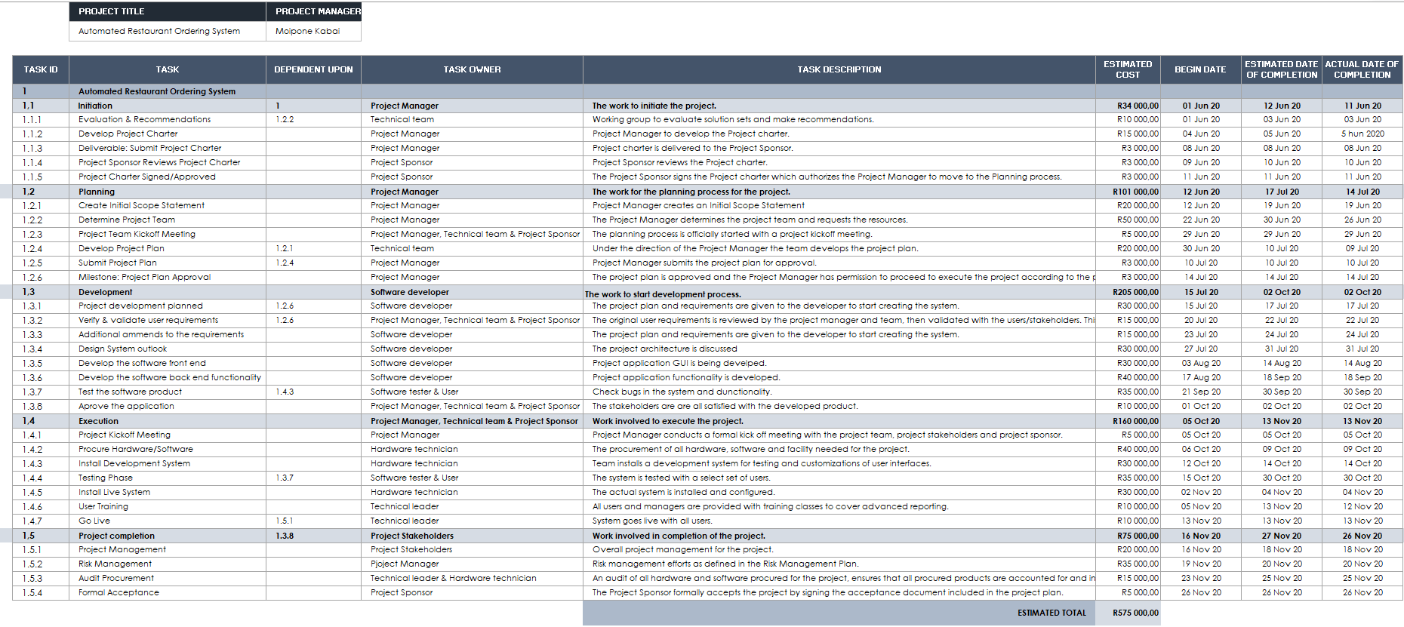

Project Selection/Justification
This project will bring so much relief to the Restaurants staff saving up on the time they use to do things that could have been done electronically. This not only benefit the staff, but the customers too by cutting off on the time they usually spent waiting for their orders to be taken to the kitchen for preparation before they could arrive to them, while some orders usually are delayed due to papers not being seen for a long time in the kitchen.
In project management, Cost/Benefit analysis estimates and totals up the equivalent monetary value of the benefits and cost of projects to establish whether they are worthwhile. This project is worthwhile as the restaurants will gain more customers because of how convenient their system will be as customers are always fascinated by new technologies which will convenience them, this will bring profit to the business and good reviews.
Time Value of Money (TVM) is an important concept in financial management. It can be used to compare investment alternatives and to solve problems involving loans, savings, etc. TVM is based on the concept that a rand that I have today is worth more than the promise or expectation that I will receive in the future due to its potential earning capacity. In this project, the money that restaurants hold today is worth more because they can invest it and earn interest. After all, they should receive some compensation for foregoing spending.
Strategic Management and Tactical Management
Due to resource-constraints most restaurants operate in a basic, non-automated and paper-based way, which result them not to having a system that does all the work for them quick and easier. Because the purpose of Rationale Management is the justification of decisions, rationale models represent the reasoning that leads to the system, including its functionality and its implementation, I will therefore use it to explain the organizational structure. It is critical in two areas namely: support of the decision making and the support in capture of knowledge. This would help the success of the project by making assumptions about the relative risks present in the development process. The development is more likely to start the tasks that are related to a recently released component as opposed to a mature one.

- Moipone Kabai is a Project Manager, who will manage the entire project.
- Abongile Mdekazi is an IT Director, who will be supervising the project manager and serve on oversight committee.
- Anati Jack is a Project Sponsor, who will provides finances for the project.
- Sinazo Madam is a Systems analyst, who will gathers requirements and analyze them in a Requirements document.
- Moliehi Mabilietse is a Software developer, who will develop the application for the required system.
- Anati Jack is a Software tester, who is responsible for testing the software to see if it meets the requirements.
- Unathi Davis is a Technical leader, who will make sure that the development team is doing what they are required to do.
- Owethu Nkanti is a Hardware technician, who ensures that the required hardware is available.
- Thandile Nxozana is a System User who will be using the system to check functionality when it is completed.

Human Resources Management
Abraham Maslow suggested that human beings possess unique qualities that enable them to make independent choices, thus giving them control over their destiny. The hierarchy of needs he developed states that people’s behaviors are guided or motivated by a sequence of needs. These needs are arranged in layers. Bottom layer needs must be met before people are concerned with the next layer above. In our project, all the needs of hierarchy will be met before anyone starts working on any piece of work until the project is finished. This is because a lack in these needs will affect the project’s performance and its effectiveness. The diagram is represented below:
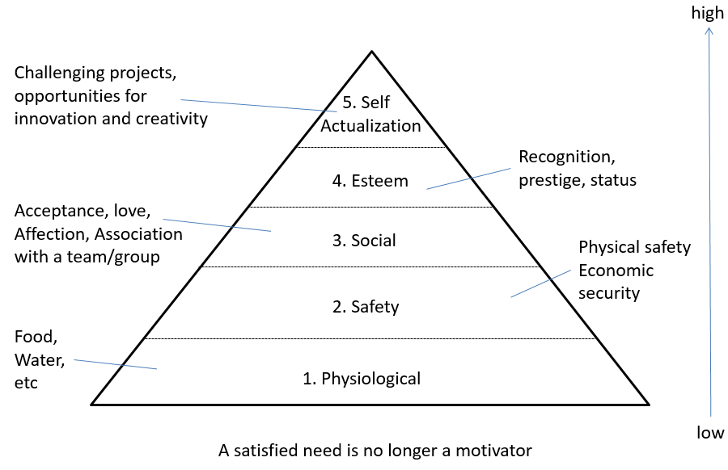
Making effective use of the people involved with a project involves four processes:
Human Resources Planning
This is where the project manager will identify and list project roles and responsibilities.
Acquiring the project team
The project manager has to get the right people to be assigned to the project team.
Developing the project team
The project team will build individual and group skills to enhance project performance.
Managing the project team
Project manager will be tracking team member performance, motivating team members, providing timely feedback, resolving issues and conflicts, and coordinating changes to enhance project performance.

Configuration Management
The following steps will be undertaken in the configuration management of my software project:
- Requirements change when developers improve their understanding of the application domain.
- The system design changes with new technology and design goals.
- The object design changes with the identification of solution objects.
- The implementation changes as faults are discovered and repaired.
- These changes can affect every work product, from the system models to the source code and documentation.
Identification of configuration items
Components of the system and its work products and their versions are identified and labeled uniquely as they serve different purposes of the system to be developed. Software developers will identify the configuration items once the deliverables and components of the system are agreed on. They will create versions and additional configuration items as the system continues to evolve.
Change control
Changes to the system and releases to users are controlled to ensure consistency with project goals. The change control will be done by software developers, project manager or by a technical team, depending on the level of quality required and the rate of change.
Status accounting
The status of individual components, work products, and change requests are recorded. This will allow developers to distinguish versions more easily and track issues related to changes. This also allows management to track project status.
Auditing
Versions selected for release are validated to ensure the completeness, consistency, and quality of the product.
Rationale Management
Rationale Management is the justification of decisions. Rationale models represent the reasoning that leads to the system, including its functionality and its implementation by supporting the decision making and capturing of knowledge. It includes the following:
Issues
In each decision making corresponds an issue to be solved so that development can proceed. An important part of the rationale is a description of the specific issue being resolved. Issues are usually phrased as questions as an issue represents a concrete problem, such as a system requirement, design, or management problem that is raised. In the restaurant system a possible issue that could be raised is the how will the waiters know when the orders are finished preparing in the kitchen.
Alternatives
This section covers the possible solutions that could address the issue that’s under consideration. These include the decisions that were explored but discarded because they did not satisfy one or more criteria. An example here could be for wait staff having to view the kitchen activities on their hand-held PDAs.
Criteria
This criteria will be used to guide decisions such that during requirements analysis, criteria are nonfunctional requirements and constraints (e.g., usability, number of input errors per day). During system design, criteria are design goals (e.g., reliability, response time) and during project management, criteria are management goals and trade-offs (e.g., timely delivery versus quality).
Argumentation
Software development decisions are not algorithmic. Developers will discover issues, try solutions and argue their relative benefits. It is only after so much discussion that an agreement is reached or a decision enforced. This argumentation occurs during all aspects of the decision process, including criteria, justifications, explored alternatives and trade-offs.
Decisions
A decision is the resolution of an issue representing the selected alternative according to the criteria that were used for evaluation and the justification of the selection. Alerting the wait staff via notification on their PDAs when the order is ready is a decision. Decisions are already captured in the system models we develop during requirements analysis and system design.
Risk Management
A source of risk is said to be any factor that can affect project performance, and risk arises when this effect is both uncertain and significant in its impact on project performance. The role of risk management is to improve project performance by way of systematic identification, appraisal and management of project related risk.
Possible Project Risks
- Personnel shortfalls
- Unrealistic schedules and budgets
- Functions being not right
- User Interface not right
- Gold-plating
- Changes in requirements
- Component shortcomings
- Performance shortfalls
- Unrealistic technical requirements

Risk | Reason
Threats to the project | Insufficient funding  Facilities not ready
Technology | Interface problems  Performance issues
People | Low skill level  Fear of change
Management | Inadequate resources  Requirements changes
Physical environment | Environment not friendly for the project
For our Project we are going to make Risk Management part of your project by identifying risks early in your project, communicate about risks as they arise to be able to find resolutions early, consider both threats and opportunities, clarify ownership issues, prioritize risks, analyze risks, plan and implement risk responses, register project risks, track risks and associated tasks.
Risk Planning
These are the steps we will follow in planning the risk we could encounter:
- Ensuring that risk cannot occur
- Reducing probability of occurrence
- Planning procedures to address risks if they do occur
- Monitoring plan
When all risks are identified, the plan our plan will include risk resolution measures.
Risk Resolution
- We define each risk by plan
- It must be achievable
- It will project anticipated results

Gantt chart

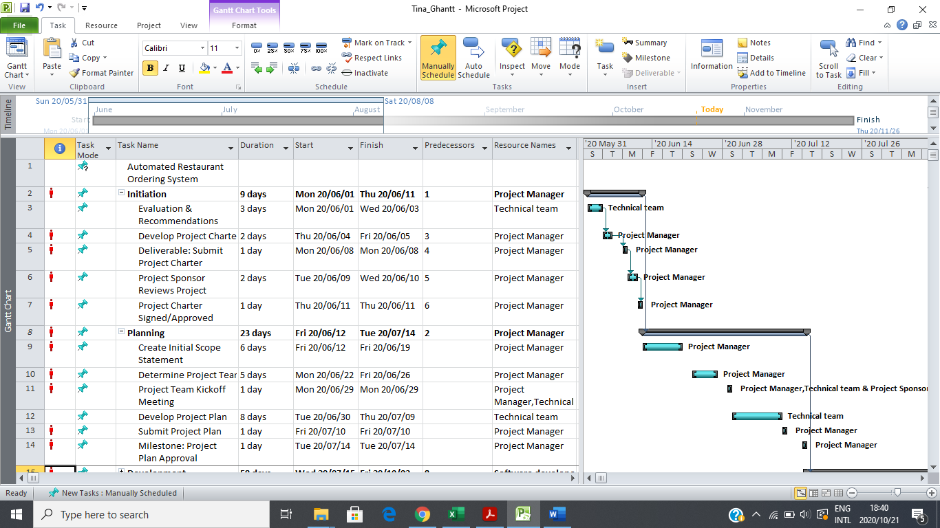

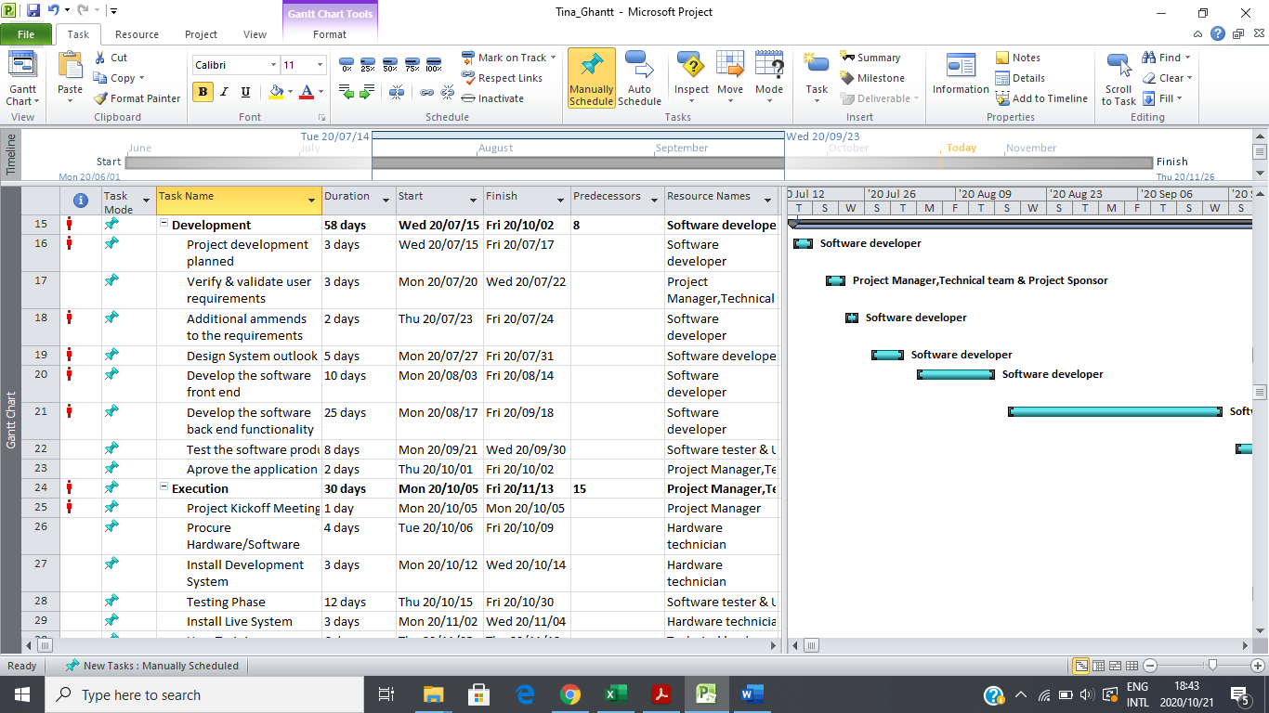
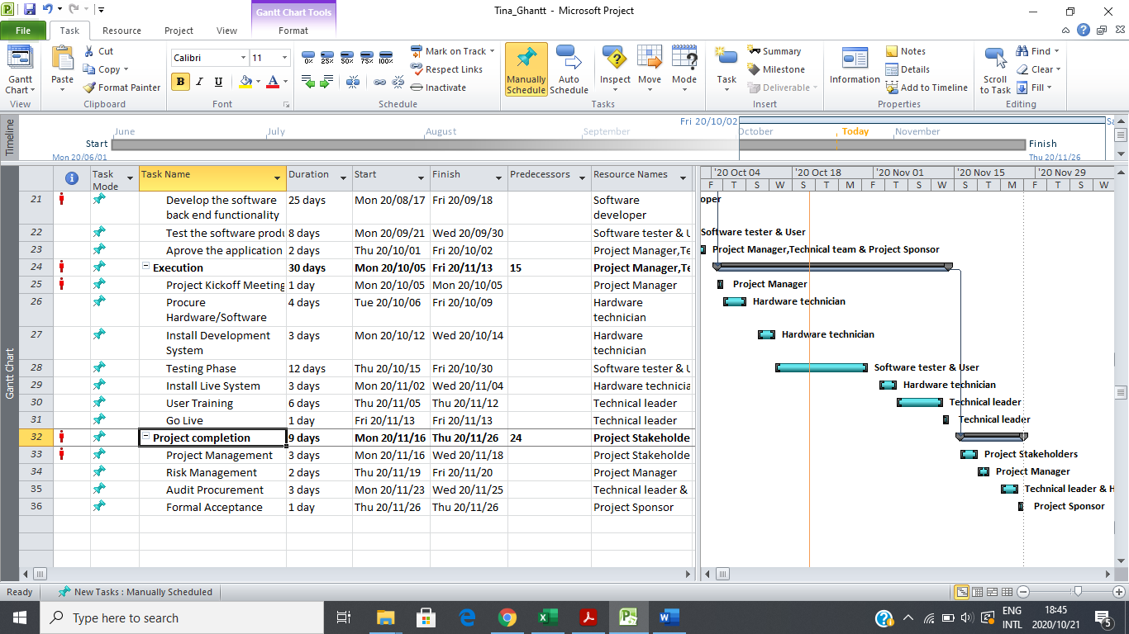
Definitions and Acronyms
Busboy: A young man who clears tables in a restaurant or cafe.
Feasibility report: A feasibility study is an assessment of the practicality of a proposed project or system.
Gantt chart: A type of bar chart that illustrates a project schedule.
Lifecycle model: A framework comprising a set of distinct high-level stages required to transform an idea of concept into reality in an orderly and efficient manner.
PDAs (Personal Digital Assistant): A personal digital assistant, also known as a handheld PC, is a variety mobile device which functions as a personal information manager.
Project Deliverables: The expected outputs that must be provided upon the completion of the project.
Scope: The tasks required to fulfill the project’s goals.
Work breakdown structure: A deliverable-oriented breakdown of a project into smaller components. A work breakdown structure is a key project deliverable that organizes the team's work into manageable sections.

Reference Material
- Clark, Wallace 1922. The Gantt chart: A Working Tool of Management. New York, NY: Ronald Press.
- Gibo, J & Clements, J.P. 2009. Successful Project Management. 4th ed. Cengage Learning.
- Haugan, Gregory T., Effective Work Breakdown Structures, pp7-8.
- Justis, R. T. & Kreigsmann, B. (1979). The feasibility study as a tool for venture analysis. Business Journal of Small Business Management 17 (1) 35-42.

